System testing Scope Approach and Strategy

DFA OneApp Drop 2

VERSION :Draft
Creation Date: March,06, 2026



1.3
3
3
3
3
5
6
7
7
7
7
8
8
8
8
9
9
9
10
10
11
11
12
12
12
13
13
14

Introduction

Purpose
The purpose of System Testing is to validate the front-end User Interface (UI) and functional behavior of the application on both mobile and web platforms. The focus is to ensure that all features operate as per the defined requirements, providing accurate functionality and a consistent user experience across supported mobile devices and browsers.
Specifically, this plan shall outline:
- The scope of system testing for mobile and web platforms is important.
- Green Epics (VF functional feature enhanced to meet TPG specific requirements) – New / Additional UI / UX changes, New / Changed interfaces.
- Functional areas and key features to be validated.
- UI verification criteria, including layout, navigation, and responsiveness.
- Supported devices, browsers, and operating systems for testing.
- Test data requirements and preparation guidelines.
- Roles and responsibilities of the testing team.
- Entry and exit criteria for system testing.
- Defect reporting and tracking process.

Project Overview
One App is a self-care application used by TPG prepaid, post-paid and fixed broadband subscribers belonging to personal and SOHO (No business customer and No experienced change between consumer and SOHO) segments to verify their consumption balance/expiry, purchase, plan change, Bills and Payments, and customer profile management through Mobile App and Web channels.

Scope

In Scope
S.No | Feature to be tested | Requirement No | Extent of Automation
 | UI Testing | 1 | Manual
 | Functional Testing (With use of Stubs) | 2 | Manual
 | Cross-Platform-testing (Google chrome) | 3 | Manual
 | Defect Management | 4 | Manual
 | Visual Validation | 5 | Manual
 | Perfecto IOS and Android (Mobile platform) | 6 | Manual

In the DFA OneApp project, the GREEN EPIC covers the modules listed below. This EPIC involves only design changes from Vodafone to TPG.

EPIC ID/IPO | EPIC NAME
1659 | OneApp | DFA | Billing | Bill Notification setting
1664 | OneApp | DFA | Billing | 19H - Update billing email address
1694 | OneApp | DFA | Billing | DD | Manage DD - Bank Account
1695 | OneApp | DFA | Billing | DD | Manage DD - Credit/debit Card
1696 | OneApp | DFA | Billing | DD | Manage DD - PayPal
1697 | OneApp | DFA | Billing | Pay bill - Authenticated
2866 | OneApp | DFA | Billing | View bill
2844 | OneApp | DFA | Billing | My bills page
2861 | OneApp | DFA | Billing | Bill detail page
2865 | OneApp | DFA | Billing | Make a payment overlay
2872 | OneApp | DFA | Billing | Something went wrong scenario's
2873 | OneApp | DFA | Billing | My bills - API issues
1853 | OneApp | DFA | Bill Est. | My bills page
1873 | OneApp | DFA | Bill Est. | Next bill page
1187 | OneApp | DFA | Product & Services | Mobile | Authenticated dashboard and My plan detail page 1/2
1926 | OneApp | DFA | Product & Services | Mobile | Authenticated dashboard and My plan detail page 2/2
1200 | OneApp | DFA | Product & Services | Mobile | Add-on | Selecting and purchase add-on journey
1286 | OneApp | DFA | Product & Services | Mobile | Add-on | Cancelling and reactivating an add-on
1947 | OneApp | DFA | Product & Services | Fixed | Add-ons | Manual Payment (1/2)
2038 | OneApp | DFA | Product & Services | Fixed | Addons | Manual payment (2/2)
1342 | OneApp | DFA | Product & Services | Mobile | Usage
4842 | OneApp | DFA | Products & Services | Mobile | Data Banking
5140 | OneApp | DFA | Products & Services | Discount Presentation for Mobile plans

Out Of Scope
- Back-end Testing: API performance testing
- CMS Integration
- Performance & Load Testing: Stress and scalability tests are not part of this cycle.
- Automation tool
- Security Testing: Vulnerability assessments and penetration testing are outside the current scope.
- Accessibility testing is out of scope
- Massive testing
- Different version of browsers
- Different version of Mobile models

Testing Strategy
System Testing will focus on validating the front-end UI and functional behavior of the application across mobile and web platforms. The primary goal is to ensure that all features meet the defined requirements and provide a consistent user experience.
Scope of System Testing:
- Validate UI elements such as layout, navigation, and responsiveness
- Verify functional workflows for supported features
- Validate the IOS and Android.
- Validated UI screens against Figma designs.
- In web testing, any one supported browser is used to execute each test case
- Ensure cross-platform consistency between mobile (Android and iOS) and web
- System Testing will include validation on both Android and iOS devices for all IPOs to ensure platform-wide functional consistency and quality.
- We will not be validating all device variations for iOS and Android. ST will be executed using one representative device for each platform.
- All defects are logged, tracked, and monitored using Zephyr

- For Web testing will do only any one of web browser
- Validated responsive view on the web application by testing in different screen sizes.

Order of Execution
- System Testing will be executed after successful completion of unit Testing and availability of a stable build in the test environment.
- Testing will be sequential, starting with a Web platform followed by a Mobile platform, to ensure defect isolation and efficient debugging.

Responsibility
- The System Testing Team will be responsible for planning, executing, and reporting system test results.
- System Tester will perform manual functionality and UI testing.
- Tester will send daily status reports via email
- Defect Management will be handled by the QA team using the agreed defect tracking tool (e.g., JIRA).
- If any defects are identified in CMS, VF code, or API components, the System Testing team will create and track a separate task in JIRA
Functional | Non- Functional
System Testing (ST) | UI testing
Functional Testing

System Testing

System Testing will be performed on the OneApp application, covering both the Mobile (Android and IOS) App and Web platforms. This stage of testing will validate the front-end UI and functional behavior of the application to ensure that all user-facing features work as per the defined requirements.

Scope
System Testing will be performed on the OneApp application, covering both Mobile App (Android and iOS) and Web platform, after successful completion of Unit Testing by developers and delivery of a stable build to the QA(ST) environment.

Objective
The objective of System Testing is to validate that all UI changes and functional components of the application are implemented correctly, display as intended across supported device and browser, and perform the expected business workflows without defects.

Responsibilities
The System Testing Lead is responsible for planning, DSR reports,coordinating and overseeing all activities related to system testing.

Test design Strategy

Timeline
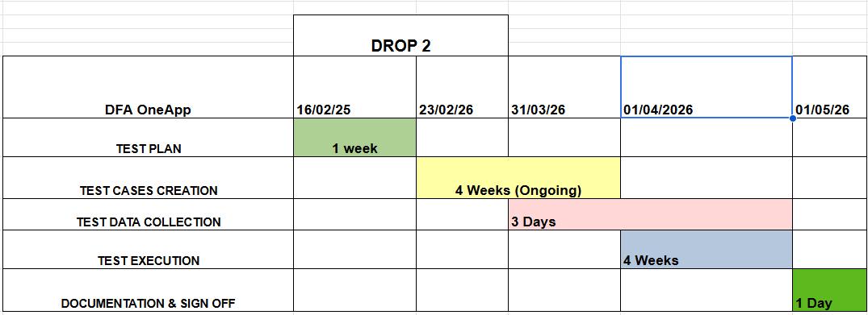

Test Data Strategy
- The usage of UI Stubs and the tools.

Test Schedule/Timetable
Testing Stage | Planned |  | Actual
Testing Stage | Start Date | End Date | Start Date | End Date
Test Strategy |  |  | 16/12/2025 | 17/12/2025
Test Planning | 16/02/2026 | 23/02/2026 | 16/02/2026 | 23/02/2026
System Test Design | 16/02/2026 | 23/02/2026 | 16/02/2026 | 23/02/2026
System Test cases preparation (ST) | 24/02/2026 | 31/03/2026 | 24/02/2026 | 31/03/2026
System Test data collection | 28/03/2026 | 01/04/2026
System Test Environment Setup | TBD | TBD
System Test execution | 01/04/2026 | 30/04/2026
System Test final reports | 01/05/2026 | 01/05/2026

Deliverables
The following are the general Testing Deliverables.
- Test Strategy
- System Test Plan
- System Test Cases
- System Test execution
- System Test data collocations
- System Test Results
- System Test DSR
- System Test Summary Report

Dependencies
- Test data (Stubs) collection is expected from the Dev team.
- System Testing Environment has been created by the Infra Team.
- System Testing is dependent on Perfecto availability for executing mobile platform tests (iOS and Android).
- Stability for system testing Environment
- Browser availability
- Only 80-85% would be able to test with stubs data which UI development team currently has.
- For other 20%, UI team need to stub the data on request from ST team (This involves dev effort and support from current OneApp SIT team for data)
- Credential from the Dev team.

Test Tools

- JIRA
- Zephyr
- Perfecto
- Firebase on https:vha.perfectomobile.com
- Figma
- Confluence
- Citrix Workspace
- Web view site: https://st04-tpg-ss.nonp.deel-fe.services.vodafone.com.au/

Test cases status
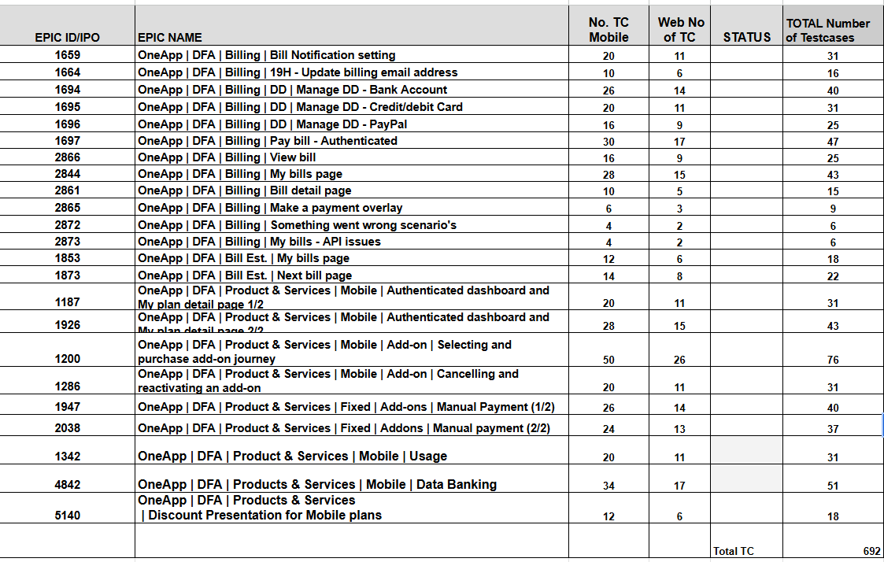

Test Suspension / Resumption Criteria
The testing fault records will contain four levels of fault severity:
1 – Critical | Fault impacts entire system(s) and testing cannot continue
2 – High | Fault impact's part(s) but not all the system(s)
3 – Medium | Fault impacts only local module(s)
4 – Low | Minor problems which do not affect functionality

Testing will be suspended for any of the following reasons (after discussions between Test Manager / Development Manager)

- Too many minor errors
- The environment is down.
- Major Error which causes the System to Hang or crash
- Error which leads to a Major change in the software
Testing will resume when sufficient evidence is provided by the development team for the fix to prove that the problem does not exist anymore.

Test Management

Test Monitoring Procedures

- Testing activities will be planned and monitored as follows:
A comprehensive Test Plan will be prepared, defining the scope, objectives, and timelines. Next, the Figma designs provided by the front-end team will be reviewed to ensure alignment with the development work. Based on these designs and requirements, detailed test cases will be created. Once finalized, the test cases will be uploaded to JIRA (Zephyr) for tracking and execution. During the execution phase, all test results and remarks will be recorded in JIRA to maintain transparency and facilitate defect management.

- Daily status meetings are conducted to review progress, discuss blockers, and plan the next steps. All updates from these meetings are documented and maintained by the Scrum Master for tracking and reporting purposes.

- Issue resolution during testing will involve performing a root cause analysis to identify the underlying problem, followed by reproducing the defect to confirm its validity and gather detailed steps for reporting. The team will ensure cross-team collaboration with developers and other stakeholders for quick resolution of complex issues. For critical or blocking defects, an escalation process will be followed to prioritize and address them promptly.

- ST will send the Daily Status Report to the TPG Test Lead, ensuring it includes a graphical representation of the execution progress along with all defect details and their status.

Test Organization with roles and responsibility

Typical Roles are

- ST Test Lead

Change Management Procedures

Entire test strategy and the resultant testing effort and schedule is subject to normal change management procedures in the event of any change in the requirements definition or design.

The process followed will be as follows:

- Analysis of Impact of the change on the strategy and the resultant effort/schedule
- Revision in schedule/effort requirement
- Get the management approval
- Proceed with the work from there on, if approved by the management

Defect Management Procedures

- All identified defects will be logged in the designated defect tracking tool (e.g., JIRA with Zephyr integration) with complete details, including steps to reproduce, screenshots, environment information, and severity.

- Once logged, the defect will be assigned to the respective developer or development team for resolution. Critical or high-severity defects will be communicated immediately through direct channels such as email or instant messaging, in addition to logging in the tool.

- Regular defect triage meetings will be conducted to review open issues, prioritize fixes, and ensure timely resolution. Status updates and progress will be tracked and reported during daily stand-ups.

- All defects are linked to their respective test cases. If a test case fails due to a defect, its status is marked as ‘Failed’. After the defect is fixed and the test is re-executed successfully, the status is updated to ‘Passed’

Sign Off Criteria

- Within the given schedule, all planned UI based and functional test cases were executed successfully across mobile and web platforms. The testing included verification of all modified and newly implemented functions, as well as newly added design elements to ensure proper layout, responsiveness, and navigation.

- Execution of Planned Test Cases: All test cases defined in the test plan have been executed successfully across both mobile and web platforms, covering all in-scope functionalities and UI validations.
- Closure of Critical and High-Severity Defects: No critical or high-severity defects remain unresolved. All such defects have been addressed, verified, and closed after successful retesting.
- Defect Management Completion: All defects identified during the testing cycle have been logged in JIRA, fixed by the development team, and retested by QA to confirm resolution. Defect status is updated and documented for final reporting.

Risk Management

S.No | Risk | Probability | Impact | Mitigation
1 | Environment & Configuration Risks | High | High | Ensure proper environment setup.
2 | Device & Browser Compatibility Risks | Medium | High | Maintain device/browser
3 | UI Risks | Medium | Medium | Perform responsive testing
4 | Test Data Risks | High | High | Use sanitized production-like data (Using stubs)
5 | Perfecto limitations | High | High | Use alternative solutions for bio metrics & OTP testing Etc.
6 | Figma and Teams access is unavailable | High | High | Give access to both as soon as possible.

Sign-off documentation
System testing team must hand over to SIT without any critical or high-severity errors.

